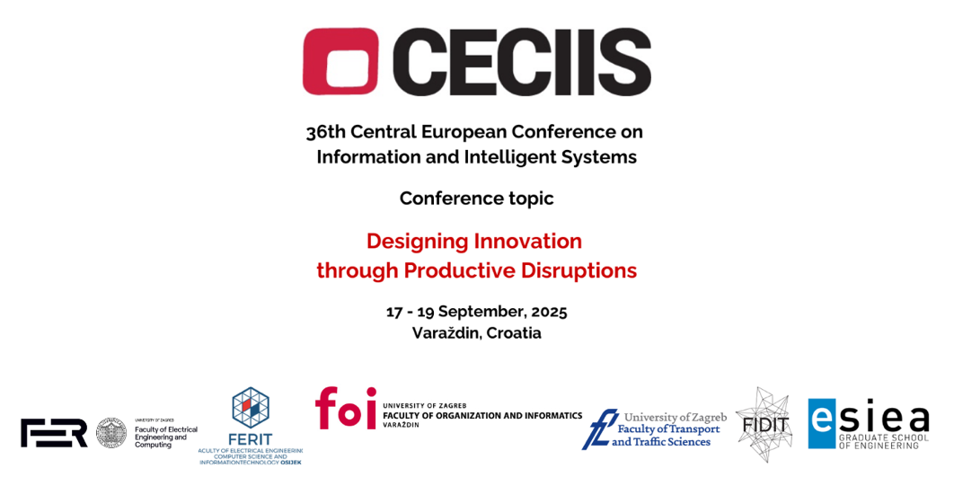

36TH CECIIS 2025 CONFERENCE AT FOI IN VARAŽDIN FROM SEPTEMBER 17TH TO 19TH

The 36th international scientific conference dedicated to information and intelligent systems - CECIIS 2025 (Central European Conference on Information and Intelligent Systems) will be held from September 17th to 19th, 2025 with this year's theme Designing Innovation through Productive Disruptions, organized by the University of Zagreb Faculty of Organization and Informatics. The opening ceremony will be held on the first day at 09:00 A.M. in the premises of the Faculty of Organization and Informatics in Varaždin. A large number of scientists, researchers, project teams and representatives of domestic and foreign educational institutions are expected at the conference.
The CECIIS conference has been held since 1989, and over the years it has changed and adapted to trends in information and communication technologies. This year's theme, Designing Innovation through Productive Disruptions, highlights emerging technologies that not only shape today’s world but also carry the transformative potential to redefine the future of society and industry.
The conference program includes four invited lectures by prominent international experts. The first day begins with a keynote lecture by Prof. Julius Georgiou, Ph.D. from the University of Cyprus, on the topic "Pushing the Boundaries of Modern Key-Enabling Technologies from Research to Innovation", followed by a panel discussion entitled "Smart Industry Way Forward". The program of the first day will also be enriched by two invited lecturers at the 15th Student Poster and Presentation Section. This year’s invited lecturers are Prof. Dr. Jin Eun Yoo from the Department of Education, Korea National University of Education (South Korea), with the lecture "Interpretable Machine Learning for the Social Sciences: Revisiting Penalized Regression in Large-Scale Analysis", and Prof. Dr. Machdel Matthee from the University of Pretoria (Republic of South Africa), with the lecture "In AI we blindly trust...".
The second day will be marked by the keynote lecture of Prof. Dr. Ing. Dennis Kolberg, Ph.D. from the Technical University of Applied Sciences Lübeck, on the topic "Approaches in Software Startups to Foster Innovative Products", as well as a guest lecture within the project DigEntre.
The conference will also host 11 scientific sections, and students will have the opportunity to present their work at the 15th Student poster and presentation section. Numerous side events are planned during the three-day program, including guest lectures, workshops of companies and foreign partner institutions, and project workshops and meetings.
The University of Zagreb Faculty of Organization and Informatics (FOI) organizes the conference in cooperation with the Faculty of Transport and Traffic Sciences, University of Zagreb, Faculty of Electrical Engineering and Computing University of Zagreb, Faculty of Electrical Engineering, Computer Science and Information Technology Josip Juraj Strossmayer University of Osijek, Faculty of Informatics and Digital Technologies,University of Rijeka and ESIEA, Graduate School of Engineering, Paris.
This year's conference attracted a large number of sponsors and donors - fifteen in total, and the list of sponsors is available on the conference's official website.

